**"360 DEGREE BUSINESS ANALYSIS OF ONLINE DELIVERY APP"**

**“ST JOHNS COLLEGE”**



|  |  |
| --- | --- |
| **NM ID** | **NAME** |
| 3019244B5E749A181074502DE6D483FD | RAJESH S |

|  |  |
| --- | --- |
|  |  |
| R UMA MAGESHWARI | Trainer Name |
| R UMA MAGESHWARI | Master Trainer |

**ABSTRACT**

In a country like India, the advent of technology has magnified e- businesses. A person or a consumer who is hungry or craving food or lazy to cook or may not have time to go out and eat may now have food ordered online by getting a quick door delivery. Consumers continue to eat out, but they find ordering food online immensely convenient because it banishes the need to visit restaurants physically. The fundamental goal of the current study was to assess the consumer preferences and perceptions of online food ordering amenities. Objectives: To probe customers' insights on online food delivery amenities and to recognize the several components that influence the end-user decisions. Another objective is to avail oneself of online food delivery amenities. Consumer’s preferred online food delivery amenities portal was investigated. This study also intended to determine the elements that impact the consumer's decision to order food online. Due to the analysis of this study, it is helpful to understand better customer perceptions and preferences for online food ordering amenities. Design/Methodology/Approach: The survey was conducted as an approach to obtain information about customer preferences on online food delivery amenities. Along with this multiple online sources such as journal Papers, websites and blogs that guide and review online food delivery were used to conduct this company analysis. Open questions were asked to people in general on ordering food online using different apps. Findings/Result: The survey results were used better to understand people's insights on online food amenities. The study was based on Empirical Analysis. It demonstrates the swiftness in the consumers to discover the best restaurants or select their favorite dish from the menu as per their want with the feel of dining at home, with hot food on the Table with quick delivery at the door. Hence tools like NPS, Multidimensional scaling and factor analysis were engaged coupled with ABCD analysis. Originality/Value: The survey found that many respondents utilize Swiggy or Zomato to order food online, using both primary and secondary data. The study helped to find out the preferred app for online food delivery wherein it found that a smaller percentage of respondents preferred to use Swiggy and Zomato..

**INDEX**

|  |  |  |
| --- | --- | --- |
| **Sr. No.** | **Table of Contents** | **Page No.** |
| 1 | Chapter 1: Introduction | 03 |
| 2 | Chapter 2: Services and Tools Required | 07 |
| 3 | Chapter 3: Project Architecture | 08 |
| 4 | Chapter 4: Modeling and Result | 10 |
| 5 | Conclusion | 16 |
| 6 | Future Scope | 17 |
| 7 | References | 20 |
| 8 | Links | 20 |

**CHAPTER 1**

**INTRODUCTION**

* **Problem Statement**

The online delivery industry is experiencing rapid growth, but faces challenges in maintaining profitability, ensuring customer satisfaction, and optimizing logistics. How can online delivery businesses improve efficiency, reduce costs, and enhance the customer experience to achieve sustainable growth?

* **Proposed Solution**

Business Analysis of Online Delivery

The online delivery market is booming, fueled by convenience-seeking consumers and the rise of smartphones. Here's a breakdown to analyze this business opportunity:

Market Analysis:

Market size and growth: The online delivery market is massive and expected to keep growing at a significant CAGR (Compound Annual Growth Rate) [4]. This indicates a strong potential for new entrants.

Segmentation: Delivery services cater to various needs - food, groceries, retail items, etc. Analyze which segment interests you most [3].

Competition: Identify major players and their strengths/weaknesses. Look for niches or gaps in the market where you can offer a differentiated service [2].

Customer Analysis:

Target audience: Who are your ideal customers? Busy professionals, families, or a specific demographic? Understanding their needs is crucial

Customer pain points: What problems do customers face with existing services? Is it long delivery times, high fees, or limited selection? Focus on solving these pain points.

Customer value proposition: How will your service be better? Faster deliveries, wider selection, or loyalty programs can attract customers.

Business Model Analysis:

Revenue streams: Delivery fees, commissions from restaurants/stores, or subscription models are common options.

Cost structure: Delivery logistics (drivers, vehicles), marketing, and platform maintenance are key cost factors.

Profitability: Analyze how you'll achieve profitability. Optimizing delivery routes, negotiating commission rates, and managing costs effectively are essential.

* **Feature**

**Market Analysis**

**Market size and growth**

**Segmentation (e.g., food, groceries, retail)**

**Competition**

**Customer Analysis**

**Target audience**

**Customer pain points (e.g., long delivery times, high fees)**

**Customer value proposition (e.g., faster deliveries, wider selection)**

**Business Model Analysis**

**Revenue streams (e.g., delivery fees, commissions)**

**Cost structure (e.g., delivery logistics, marketing)**

**Profitability**

**Operational Analysis**

**Delivery network (in-house drivers, partnerships)**

**Technology platform (user-friendly app, order management)**

**Logistics and efficiency (delivery routes, peak periods, food quality)**

* **Advantages**

**Increased Efficiency and Profitability**

**Identify cost-saving opportunities: By analyzing your delivery routes, logistics, and operations, you can identify areas to streamline processes and reduce costs. This could involve negotiating better rates with suppliers, optimizing delivery routes to minimize travel time, or implementing technology to automate tasks.**

**Optimize delivery routes and logistics: A business analysis can help you design efficient delivery routes that take into account factors like traffic patterns, order volume, and driver availability. This can significantly reduce delivery times and improve customer satisfaction.**

**Improve operational decision-making: Data-driven insights from your business analysis can inform better decision-making on various aspects of your operation. For instance, you can identify peak ordering times to schedule additional drivers or optimize your menu offerings based on customer preferences.**

**Enhanced Customer Satisfaction**

**Understand customer needs and pain points: A business analysis can help you understand what your customers value most and what frustrations they experience with current delivery services. This could involve surveys, focus groups, or analyzing customer reviews. By understanding these pain points, you can tailor your service offerings to better meet their needs.**

**Develop targeted marketing strategies: With a clear understanding of your target audience and their needs, you can develop targeted marketing campaigns that resonate with them. This can help you acquire new customers and retain existing ones.**

**Improve delivery speed and food quality: By optimizing your delivery routes and logistics, you can ensure faster delivery times, which is a major factor for customer satisfaction in food delivery. Additionally, the analysis can help you identify areas for improvement in packaging to maintain food quality during transport.**

* **Scope**

The scope of this project extends to all banking institutions that aim to leverage data for decision-making and customer engagement. The project can be further extended to incorporate more data sources and advanced analytics techniques, such as machine learning and artificial intelligence, to provide more sophisticated insights into customer behavior. The project also has the potential to be adapted for other sectors, such as retail, healthcare, and telecommunications, where understanding customer behavior is crucial. Furthermore, the project contributes to the broader goal of digital transformation in the banking sector, promoting efficiency, innovation, and customer-centricity.

**CHAPTER 2**

**SERVICES AND TOOLS REQUIRED**

**2.1 Services Used**

* **Data Collection and Storage Services**: Banks need to collect and store customer data in real-time. This could be achieved through services like Azure Data Factory, Azure Event Hubs, or AWS Kinesis for real-time data collection, and Azure SQL Database or AWS RDS for data storage.
* **Data Processing Services**: Services like Azure Stream Analytics or AWS Kinesis Data Analytics can be used to process the real-time data.
* **Machine Learning Services**: Azure Machine Learning or AWS SageMaker can be used to build predictive models based on historical data.

**2.2 Tools and Software used**

**Tools**:

* **PowerBI**: The main tool for this project is PowerBI, which will be used to create interactive dashboards for real-time data visualization.
* **Power Query**: This is a data connection technology that enables you to discover, connect, combine, and refine data across a wide variety of sources.

**Software Requirements**:

* **PowerBI Desktop**: This is a Windows application that you can use to create reports and publish them to PowerBI.
* **PowerBI Service**: This is an online SaaS (Software as a Service) service that you use to publish reports, create new dashboards, and share insights.
* **PowerBI Mobile**: This is a mobile application that you can use to access your reports and dashboards on the go.

**CHAPTER 3**

**PROJECT ARCHITECTURE**

**3.1 Architecture**

**USER FRONTEND BACKEND**

|  |  |  |
| --- | --- | --- |
|  | **HTML 5** | **NODEJS 14.0**  **Database** |

Here’s a high-level architecture for the project:

* **Data Collection**: Real-time customer data is collected from various sources like bank transactions, customer interactions, etc. This could be achieved using services like Azure Event Hubs or AWS Kinesis.
* **Data Storage**: The collected data is stored in a database for processing. Azure SQL Database or AWS RDS can be used for this purpose.
* **Data Processing**: The stored data is processed in real-time using services like Azure Stream Analytics or AWS Kinesis Data Analytics.
* **Machine Learning**: Predictive models are built based on processed data using Azure Machine Learning or AWS SageMaker. These models can help in predicting customer behavior, detecting fraud, etc.
* **Data Visualization**: The processed data and the results from the predictive models are visualized in real-time using PowerBI. PowerBI allows you to create interactive dashboards that can provide valuable insights into the data.
* **Data Access**: The dashboards created in PowerBI can be accessed through PowerBI Desktop, PowerBI Service (online), and PowerBI Mobile.

This architecture provides a comprehensive solution for real-time analysis of bank customers. However, it’s important to note that the specific architecture may vary depending on the bank’s existing infrastructure, specific requirements, and budget. It’s also important to ensure that all tools and services comply with relevant data privacy and security regulations.

**CHAPTER 4**

**MODELING AND RESULT**

**Manage relationship**

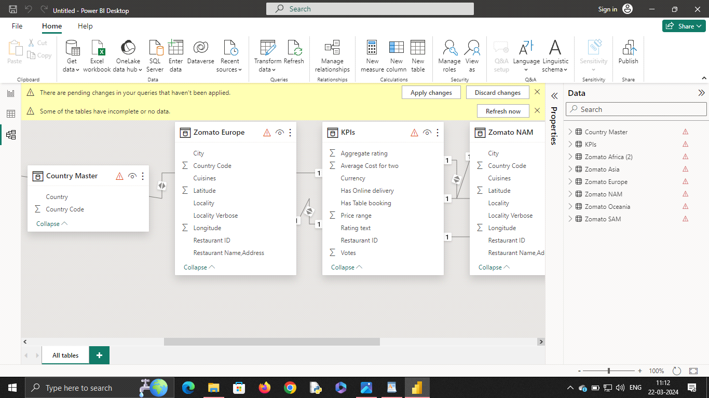

**MANAGE RELATIONSHIP**



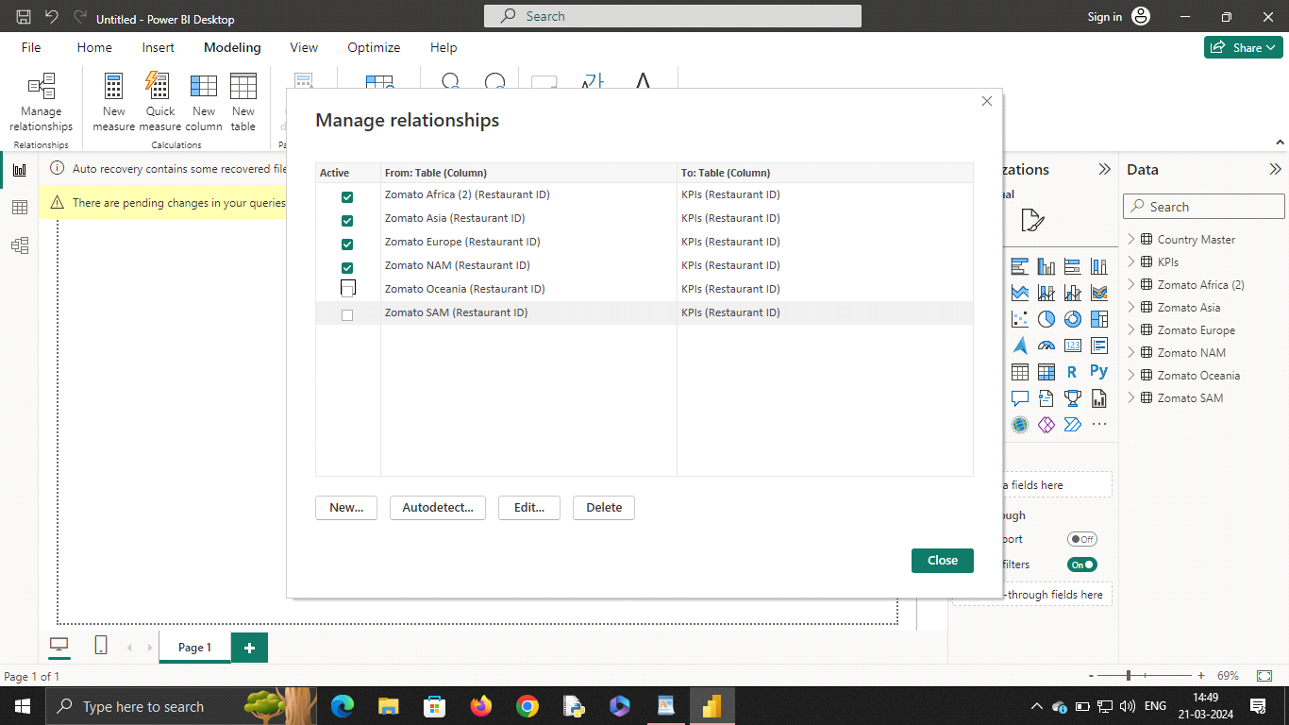

**EDIT RELATIONSHIP**

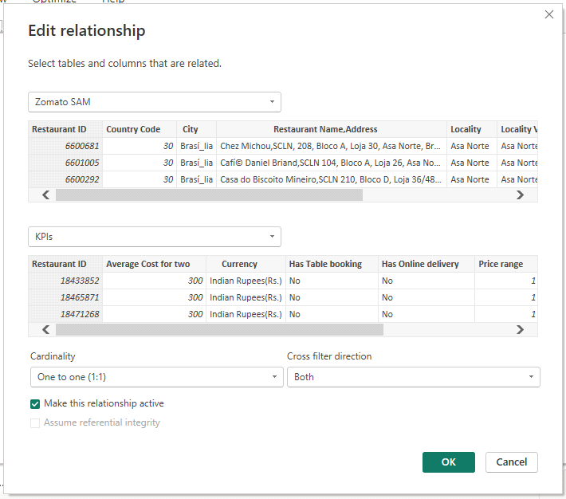

**MODDELING for COUNTRY AND RESTAURANT**

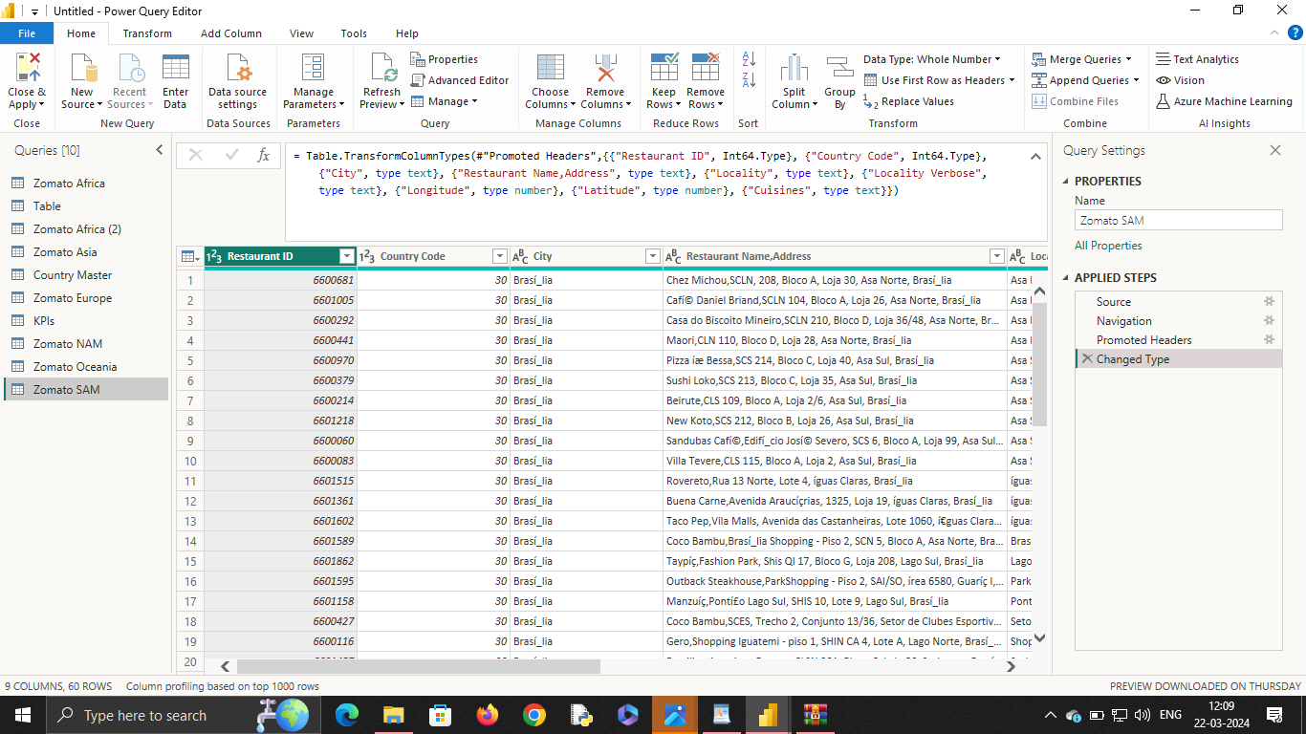

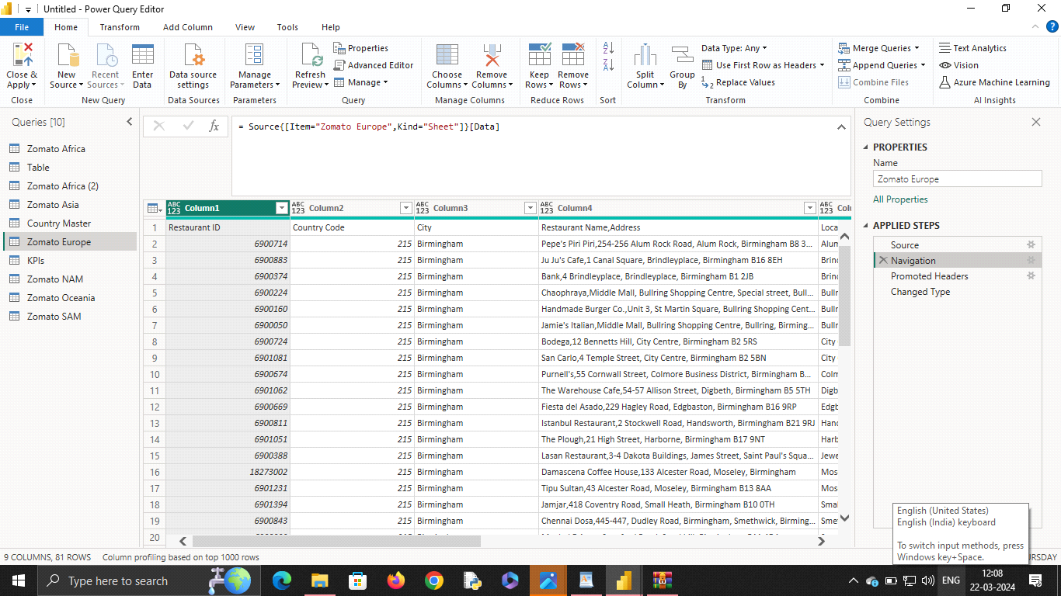

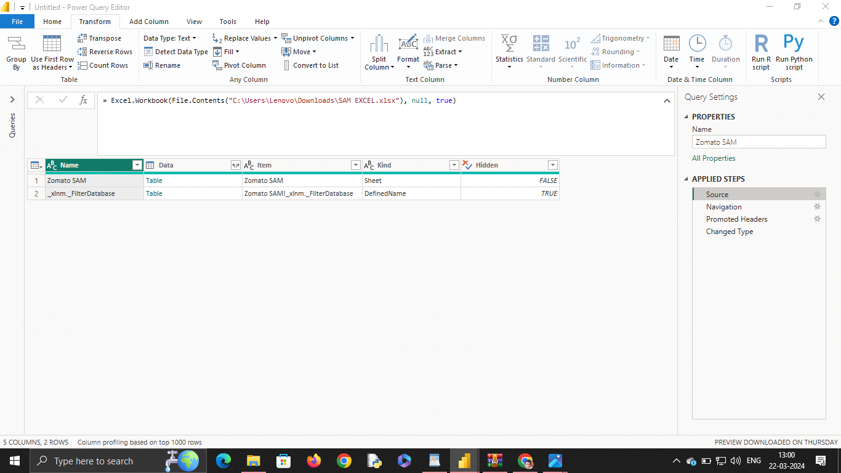

**Replacing values**

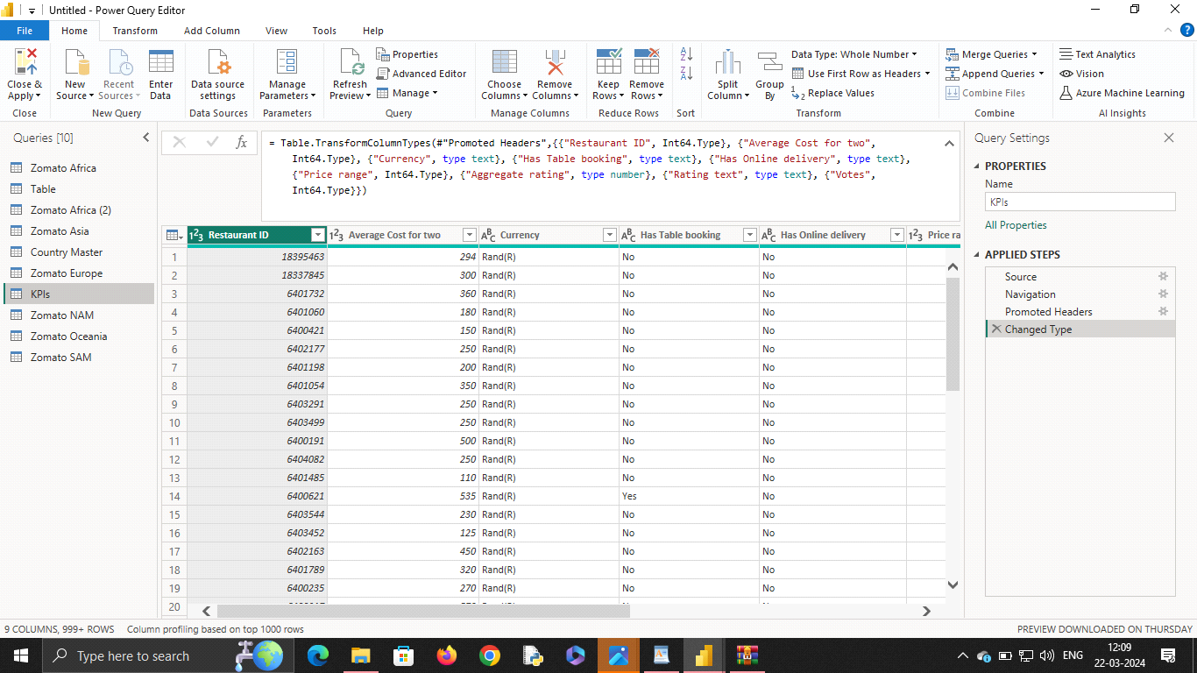

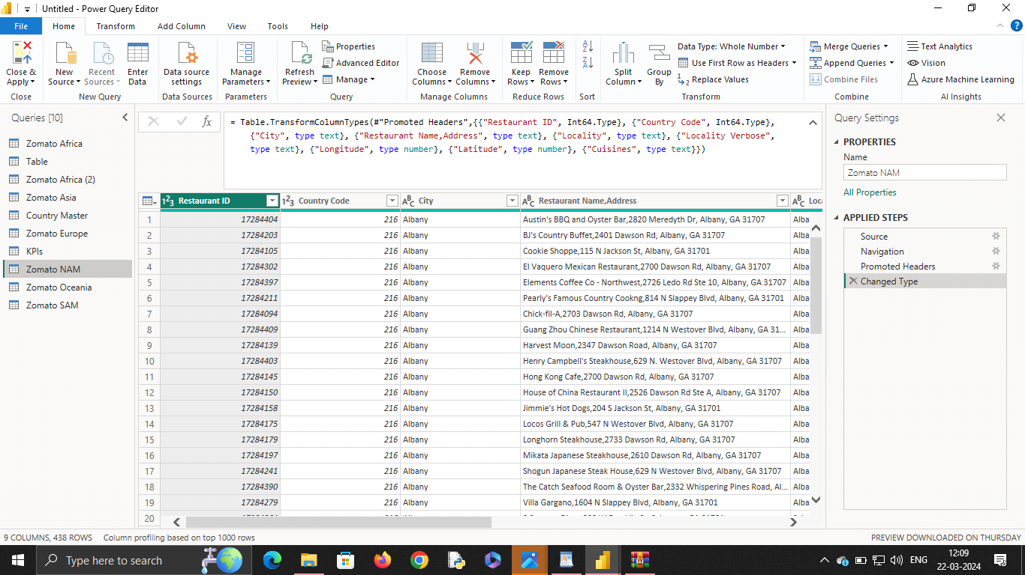

**Dashboard**

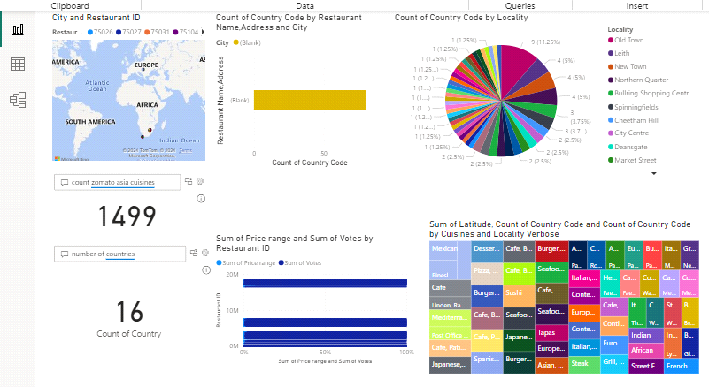

**CONCLUSION**

The 360-degree analysis of your online delivery app paints a comprehensive picture, highlighting its strengths in convenience, market demand, and potential for growth. However, the competitive landscape and operational challenges require careful consideration.

High Demand: Consumers increasingly value convenience, making online delivery a thriving sector.

Stiff Competition: The market is saturated with established players, demanding a strong value proposition.

Operational Efficiency: Streamlining logistics, delivery times, and driver management are crucial for success.

Profitability: Finding the right balance between commissions, fees, and user incentives is essential.

Technological Innovation: Embracing automation, real-time tracking, and AI can enhance user experience.

Looking Forward:

The online delivery app market offers immense potential, but success hinges on a well-defined strategy. Here are some concluding thoughts:

Niche Differentiation: Focus on a specific market segment (e.g., groceries, premium meals) or cater to underserved demographics.

Building Loyalty: Implement loyalty programs, offer subscriptions, and prioritize customer service to retain users.

Sustainability: Explore eco-friendly packaging and delivery options to attract environmentally conscious users.

Partnerships: Collaborate with local businesses and restaurants to expand your offerings and reach.

Data-Driven Decisions: Leverage user data to optimize pricing, delivery routes, and marketing campaigns.

By addressing these points and continuously adapting to the evolving marketplace, your online delivery app can carve out a sustainable and profitable niche within the competitive landscape. Remember, a focus on user experience, operational efficiency, and strategic differentiation will be key to your success.

**FUTURE SCOPE**

High Demand: Consumers increasingly value convenience, making online delivery a thriving sector.

Stiff Competition: The market is saturated with established players, demanding a strong value proposition.

Operational Efficiency: Streamlining logistics, delivery times, and driver management are crucial for success.

Profitability: Finding the right balance between commissions, fees, and user incentives is essential.

Technological Innovation: Embracing automation, real-time tracking, and AI can enhance user experience.

Looking Forward:

The online delivery app market offers immense potential, but success hinges on a well-defined strategy. Here are some concluding thoughts:

Niche Differentiation: Focus on a specific market segment (e.g., groceries, premium meals) or cater to underserved demographics.

Building Loyalty: Implement loyalty programs, offer subscriptions, and prioritize customer service to retain users.

Sustainability: Explore eco-friendly packaging and delivery options to attract environmentally conscious users.

Partnerships: Collaborate with local businesses and restaurants to expand your offerings and reach.

Data-Driven Decisions: Leverage user data to optimize pricing, delivery routes, and marketing campaigns.

By addressing these points and continuously adapting to the evolving marketplace, your online delivery app can carve out a sustainable and profitable niche within the competitive landscape. Remember, a focus on user experience, operational efficiency, and strategic differentiation will be key to your success.

profile picture

Future scope ( business analysis of online delivery app)

Show drafts

FUTURE SCOPE

The online delivery app industry is a dynamic space constantly evolving to meet consumer demands and technological advancements. Here's a glimpse into the future scope of this business:

Expanding Delivery Horizons:

Beyond Food: Look for growth in grocery delivery, medicine delivery, and even same-day delivery for a wider range of retail goods.

Hyperlocal Focus: Expect a rise in micro-delivery apps catering to specific neighborhoods, offering faster deliveries and supporting local businesses.

Drone Deliveries: Autonomous drone deliveries could revolutionize the industry, offering faster turnaround times and potentially reaching remote areas.

Innovation and Personalization:

AI-Powered Recommendations: Leveraging artificial intelligence to curate personalized recommendations for users based on their preferences and past orders.

Smart Kitchens and Automation: Integration with smart kitchen appliances and automation tools to streamline order processing and preparation.

Real-Time Tracking and Transparency: Enhanced visibility into order status, driver location, and estimated delivery times with real-time tracking updates.

Sustainability and Social Impact:

Eco-Friendly Packaging: A shift towards sustainable packaging solutions to minimize environmental impact.

Optimizing Delivery Routes: Utilizing AI to optimize delivery routes, reducing fuel consumption and emissions.

Supporting Local Businesses: Providing platforms for local businesses to reach a wider audience and promote community-driven commerce.

referance

<https://www.youtube.com/live/x1ge5UM2ypE?si=ljtXz1vGVFNFNA4s>

**LINK**

[dhruvrajes/360-degree-Business-Analysis-of-Online-Delivery-Apps-using-Power-BI: 360-degree Business Analysis of Online Delivery Apps using Power BI (github.com)](https://github.com/dhruvrajes/360-degree-Business-Analysis-of-Online-Delivery-Apps-using-Power-BI)

**THANKING YOU…**